yazı tipi, grafik, logo, grafik tasarım içeren bir resim

Açıklama otomatik olarak oluşturuldu

PROJECT REPORT OF

**ADJUSTABLE LİGHTİNG MODULE FOR LOW LİGHT CONDİTİONS**

(Subtractor Circuit Design)

Department of Computer EngineerinG

Module Courses:

➢ Programming

➢ Physics II

➢ Calculus II

➢ Circuit Theory I

Project Topic: 2

Student’s Number:

220201023

Student’s Name:

Mehmet Yasin UZUN

github.com/mehmetyasinuzun

Table 1: Project Details

|  |  |
| --- | --- |
| **Project Name** | Adjustable Lighting Module for Low Light Conditions |
| **Circuit Type** | Subtractor Circuit Design |
| **Name, Surname** | Mehmet Yasin UZUN |
| **Student Id Number** | **220201023** |
| **e-mail** | **mehmetyasinuzun@gmail.com** |
| **Academic Advisor** | **Sıtkı Akkaya**  **Metin Zontul**  **Sabit Horoz**  **Bahar Kuloğlu** |
| **Github URL** | **github.com/mehmetyasinuzun** |

Table 2: Individual Contributions Overview

|  |  |
| --- | --- |
| **Name, Surname** | **Summary of Contributions to the Module Project Document** |
| Mehmet Yasin UZUN | In the Module project, I was responsible for the circuit design, simulation and testing phases. Using the LM741 and 7905 integrates, I designed a 0-10 V adjustable voltage source and verified the functionality of the circuit with Proteus simulations and laboratory tests. By managing the material selection, circuit installation and optimization processes, I have developed an effective solution that saves energy in low light conditions. |

# Executive Summary

This project was designed using the LM741 operational amplifier and the 7905 negative voltage regulator in order to provide an energy-efficient and adjustable lighting source in low-light conditions. The circuit works with a reference voltage of -5 V and provides an adjustable output in the December range of 0-10 V. Thanks to the potentiometer, the LED brightness can be controlled precisely.

The project process included simulation, circuit design and laboratory tests and lasted 4-5 weeks in total. Despite the delays, the goals were successfully achieved with the support of theoretical information and Proteus simulations. As a result, an effective lighting solution has been developed that protects nighttime metabolism and saves energy.

# TABLE OF CONTENTS

Executive Summary 3

TABLE OF CONTENTS 4

LIST OF TABLES 5

TABLE OF FIGURES 6

**INTRODUCTION** 7

**What are the Op-Amps?** 7

**Operational Amplifier Terminals** 7

**General Information** 9

What is a 7905 Negative Voltage Regulator? 13

**1. Scope** 14

**2. Project Schedule** 15

**2.1 Work Packages & Dependencies** 15

**2.2 Resource Requirements** 16

**3. Course Contributions and Project Effort** 17

**3.1 Calculus** 17

**3.2 Physics** 19

**3.3 Circuit I** 20

**3.4 Algorithm and Programming** 24

**3.5 Integration and Overall Effort** 26

**3.6 Discussion** 26

**4. Discussions** 27

**4.1 Limitations and Constraints** 27

**4.2 Health and Safety Issues** 27

**4.3 Legal Issues** 27

**4.4 Economic Issues and Constraints** 28

**4.5 Sustainability** 28

**4.6 Ethical Issues** 28

**4.7 Multidisciplinary Collaboration** 28

**4.8 Real-World Problem Solving** 28

**4.9 Alignment with Industry Applications** 29

Margin of Error Classification 29

As a result 30

**References** 30

# LIST OF TABLES

Table 1: Project Details...……………………………………………………………....2

Table 2: Individual Contributions Overview...…………………………...……2

Table 3………………………………………………………………………………………...19

# TABLE OF FIGURES

Figure 1 LM741…………………………………………………………………………………………...………….7

Figure 2 Pinout Diagram for the LM741 Operational Amplifier………………………….......….8

Figure 3 The Circuit Symbol for Operational Amplifier…………………………........................... 8

Figure 6 an ideal inverting operational amplifier circuit with output voltage marked. 11

Figure 7 7905 Voltage Regulator Connection Ends……………………………………………….….13

Figure 9 First Condition’s Oscilloscope Readings……………………………………………….…....17

Figure 12……………………………………………………………………………….............................................11

Figure 13…………………………………………………………………………………………………….…………22

Figure 14…………………………………………………………………………………………………………….…22

Figure 15………………………………………………………………………………………………………….……23

Figure 16…………………………………………………………………………………………………………….…23

Figure 17…………………………………………………………………………………………….…………………23

Figure 18………………………………………………………………………………………………………….……23

Figure 19…………………………………………………………………………………………………………….…23

**INTRODUCTION**

**What are the Op-Amps?**

An Operational Amplifier is a very high-gain, direct-coupled amplifier that uses feedback for control of its response characteristic. A direct-coupled amplifier is capable of amplifying DC as well as time varying signals.

Operational amlifier circuits were first used as basic building blocks in analog computers. The term *operational* refers to op amp circuits that implement mathematical operations sıch as integration, differentiation, addition, sign changing, and scaling. While the range of applications has broadened beyond implemeting mathematical operations the name for the circuit persists.

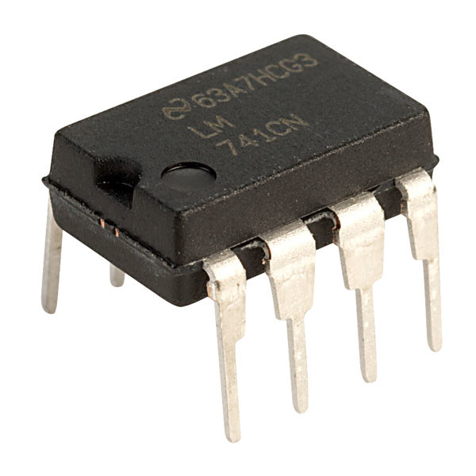An example for an op-amp ( LM741 ) is shown below (Figure 1).

Figure 1 LM741

**Operational Amplifier Terminals**

Despite having 8 pins, an operational amplifier typically has five main terminals:

* Inverting input,
* Noninverting input,
* Output,
* Positive power supply (V+)
* Negative power supply (V-)

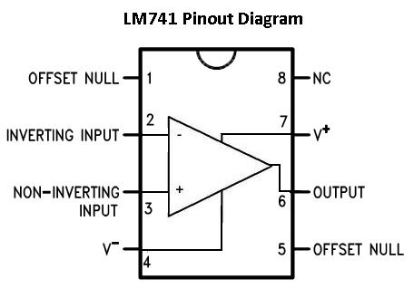Figure 2 shows the Pinout Diagram for the LM741 Operational Amplifier.

Figure 2 Pinout Diagram for the LM741 Operational Amplifier

Except the terminals that we have mentioned the remaining three terminals are little or no concern. The two offset null terminals may be used in an auxiliary circuit that compensates for performance degredation owing to aging and imperfections. These terminaks are seldom sued because degradation is usually negligible. Terminal 8 is an unused terminal NC stands for no connection.

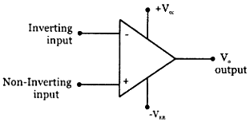 Figure 3 shows common circuit symbol for an op amp that contains the five terminals of primary interest.

Figure 3 The Circuit Symbol for Operational Amplifier

Figure 4 Equivelant Circuitl for Operational AmplifierFigure 5 The Circuit Symbol for Operational Amplifier

The non-inverting input terminal is labeled plus (+), and the inverting input terminal is labeled minus (-). The power supply terminals, which are always drawn outside of the triangle, are marked with +V and -V. The terminal at the tip of the triangle is always understood to be the output terminal.

**General Information**

Figure 4 shows the equivelant circuit for an operational amplifier.While V1 represents the inverting input V2 is representing the non-inverting input. V0 is the output voltage. And there is a dependent voltage source it depends on the value which is the potential difference between the input terminals.

Figure 6 Equivelant Circuitl for Operational Amplifier

Figure 7 an ideal inverting operational amplifier circuit.Figure 8 Equivelant Circuitl for Operational Amplifier

Since an Operational Amplifier is a voltage controlled voltage source the output voltage of an op-amp is the difference between the voltages applied to its input terminals multiplied by its open loop gain, A.

If voltage across the inverting and non inverting terminal are same general equaiton for the open loop gain is:

The output voltage becomes positive when the voltage applied to the positive (non-inverting) input exceeds the voltage applied to the negative (inverting) input. Since an ideal Dec-amp has an infinite open circuit gain, the difference between (V+) (positive input) and (V-) (negative input) must be infinitely small in order for the output voltage to remain at a finite value.

Therefore, when performing circuit analysis, it is assumed that this voltage difference is zero. Also, an ideal op-amp should have infinite input impedance and zero output impedance. These characteristics represent the ideal of a buffer booster, which is necessary to drive a low-impedance load with a large-impedance source.

In circuit analysis, it is assumed that the current passing through the input terminals is zero. In addition, it is assumed that the output voltage is the same as the open circuit output voltage when the load is driven.

So ideal op amps have 2 assumptions as it follows:

* 1. No current flowing in and out of the input terminals of the op-amp.
  2. If the output is not in saturation, the voltage between the inverting and non-inverting input terminals is zero.

By using those two rules we can find output voltage by using the output voltage of an inverting operational amplifier formula, which is:

Where:

* is the output voltage,
* A is the gain,
* is the input voltage.

If the input voltage is known the only thing that is needed to find the output voltage is the gain. Gain can be found by applying those assumptions to a inverting operational amplifier circuit. Figure 5 shows an ideal inverting operational amplifier circuit.

Figure 9 an ideal inverting operational amplifier circuit.

Figure 10 an ideal inverting operational amplifier circuit with output voltage marked.Figure 11 an ideal inverting operational amplifier circuit.

The circuit in the Figure 5 is an inverting operational amplifier (op-amp) configuration. It consists of an op-amp with its non-inverting input (+) connected to ground. The input voltage Vi​ is applied to the inverting input (-) through a resistor R1​. The inverting input is also connected to the output Vo​ through a feedback resistor Rf. The input current I1​ flows through R1​, and the current I2​ flows through Rf​. According to the diagram, no current enters the op-amp's input terminals. The voltage at the inverting input is labeled as V1​, which is marked as 0V. The output voltage is labeled as Vo​, and the currents through the resistors are indicated as I1​ and I2​. The direction of current flow and the connection of components are clearly marked, showing the typical structure of an inverting amplifier circuit.

As it can be seen from the Figure 5 the non-inverting input terminal is connected to the ground so It’s potential equals to 0Volts. According to the second rule we know the first terminals to be precise the inverting input terminal’s potential should be equal to 0 as well.

If and Then

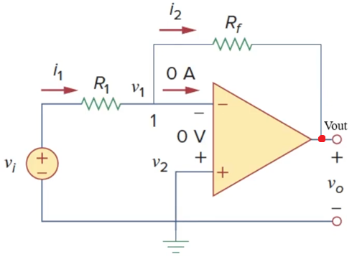If we mark the the node at the tip of the op-amp and call it’s potential Vout we can analize this circuit using Circuit Analysis methods and understand the relationship between Vi which is the input voltage and the Vout which is the output voltage. Figure 6 shows the same circuit with Figure 5 but the Vout is marked with a red dot.

Figure 12 an ideal inverting operational amplifier circuit with output voltage marked.

Figure 13 Output Graph of A Saturated Op-AmpFigure 14 an ideal inverting operational amplifier circuit with output voltage marked.

To decipher the relationship between Vi and Vout, KCL (Kirchhoff Current Law) can be applied at the node marked with the number 1 in Figure 6.

For node 1:

Since it’s an ideal op-amp there is no need to think about the current which is entering the inverting input because of the first rule.

For ,

and since we know equals to 0,

For ,

and since we know equals to 0,

So,

If

Then

And if we rearrenge the equaiton a bit we find the relationship between Vin and Vout as:

If

and

Then

And by like this In ideal op-amp circuits, the gain can be expressed as the negative ratio of the feedback resistance() to the input resistance ().

## What is a 7905 Negative Voltage Regulator?

The 7905 negative voltage regulator is a voltage regulator integrated that provides a constant output voltage of -5V. This regulator keeps the output voltage constant despite input voltage changes and is often used in power supply circuits to provide a stable negative reference voltage. It provides constant voltage in both DC and time-dependent signals.

The 7905 is usually used in power management applications to ensure the stable operation of low-voltage devices. This integrated can operate over a wide input voltage December and keeps the output stable by dissipating excess power as heat.

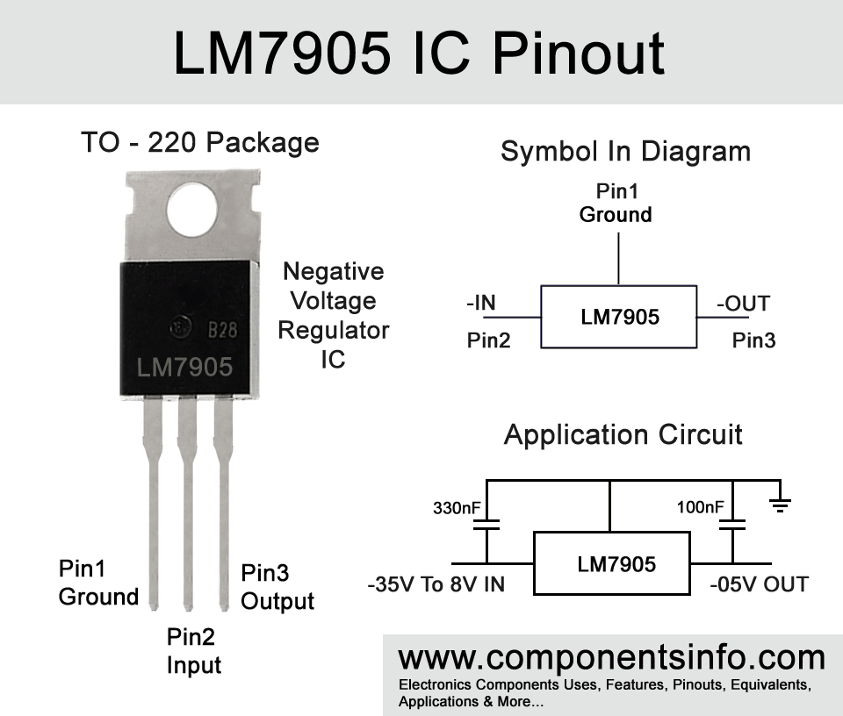

*Figure 7 7905 Voltage Regulator Connection Ends*

the 7905 integrator has 3 main connection ends:

* Pin2 Input: The input voltage is applied to this terminal. The input voltage should usually be between -7V and -25V.
* Pin1 Ground: It is the reference point of the regulator and the measurement of negative voltages in the circuit is made according to this point.
* Pin3 Output (Output): Constant -5V output voltage is supplied from this terminal.

These connection ends form the basic building blocks for the correct operation of the 7905 integrator and increase the stability of the circuit by providing a constant negative voltage.

**1. Scope**

In the adjustable lighting module in low light conditions, it was aimed to obtain a sensitive and adjustable lighting source at low light levels by using the LM741 operational amplifier (OpAmp). In the project, -5 V was obtained by using 7905 regulator integrator as a negative voltage source and this voltage was applied to the inverter input of OPAMP. The gain of the circuit is designed in such a way that it can vary Decently between 2 and 0. Therefore, when -5 V is applied at the inverter input, the output voltage can be adjusted in the December range of 0-10 V thanks to the potentiometer.

The main goal is to provide adequate and adjustable lighting without exhausting the human eye at night or in low-light conditions. In particular, it is included in the scope of the project to prevent high-brightness bulbs from negatively affecting nighttime metabolism, to save energy and, if necessary, to illuminate the place with as low-brightness light as possible (for example, during wartime).

In this project, LM741 OpAmp, 7905 negative voltage regulator, 10 kΩ potentiometer, 5 kΩ resistor, LEDs (white), voltmeter and two separate 12 V, 1 A adapters were used. During the project, circuit design, material selection, simulation in the Proteus environment and installation and testing in the real environment were carried out.

Those Who Are Excluded from the Scope

* High power lighting designs,
* Color changing (RGB) LED applications,
* Microcontroller-based control systems.

In this report, the steps followed during the project, the course information used in circuit design, economic and sustainability dimensions, health and safety measures and project management processes will be explained in particular.

**Those Who Are Excluded from the Scope**

* High power lighting designs,
* Color changing (RGB) LED applications,
* Microcontroller-based control systems.

In this report, the steps followed during the project, the course information used in circuit design, economic and sustainability dimensions, health and safety measures and project management processes will be explained in particular.

**2. Project Schedule**

The project was originally planned to last 3 weeks, but as a result of the failures, it was completed in about 4-5 weeks in total. The delays and stages experienced in this process are as follows.

**2.1 Work Packages & Dependencies**

The basic work packages in the project and the rankings of these work packages are as follows:

1. **Preliminary Research and Planning (Week 1, Day 1-5)**
   * Preliminary information was collected about the operational amplifier (LM741) and the negative voltage regulator (7905).
   * The basic circuit diagram was created in Proteus and different gain scenarios were tried.
   * The required components (resistors, potentiometer, LED, voltmeter, etc.) the list was prepared.
2. **Material Supply and Simulation Development (Week 1-2, Day 6-10)**
   * Ordering the necessary elements (adapters, potentiometer, voltmeter, etc.).
   * Elaboration of Proteus simulation and analysis of circuit behavior with virtual measurements.
3. **Installation in a Real Environment (2-3 Weeks, 11-20 Days)**
   * Receiving the delivery of the materials and starting the circuit installation in the laboratory.
   * Examination of the datasheets of the LM741 and 7905 integrates.
   * Soldering of the necessary elements in the circuit, making power connections and taking protective measures (insulation with insulated tape, using female cables to avoid possible electrical contact, etc.).
4. **Tests and Corrections (Week 4, Days 20-25)**
   * By adding a voltmeter to the circuit, continuous monitoring of the output voltage was ensured.
   * The controllability of the brightness level of the LEDs via the potentiometer was tested.
   * DThe circuit was successfully operated in such a way that it outputs between 0-11.3V (idle) and 0-9.22V (under load).

**Milestones**

* **Milestone 1:** Successful completion of the Proteus simulation.
* **Milestone 2:** Installation of the real circuit in the laboratory.
* **Milestone 3:** Final test and approval — stable 0-10 V adjustable output of the circuit.

**2.2 Resource Requirements**

* **Personnel:** The project was carried out by a single person. No counselling or additional support was received.
* **Hardware:**
  + 2 pcs 12 V, 1 A adapter (~370 TL)
  + LM741 (~70 TL)
  + 7905 negative voltage regulator
  + 10 kΩ potentiometer (35 TL)
  + 5 kΩ resistance
  + 15 white LEDs (total ~50 TL)
  + Voltmeter (~150 TL)
  + Soldering station, multimeter, connecting cables, insulated tape, etc.
* **Software:**
  + Proteus (for circuit simulation)
  + C/C++ is a software that calculates the operations performed in the circuit
* **Total Cost**: About 1000-1500 TL (this cost also includes different circuit parts that were tried until we decided on the final circuit). In addition, no fee has been paid for the use of the laboratory, the university's facilities have been used.
* **Time:** A total of 3 weeks (design, planning, installation and testing).

**3. Course Contributions and Project Effort**

In this section, it is explained how the knowledge and skills acquired from different courses during the project contribute to the project solution.

**3.1 Calculus**

In the Adjustable Lighting Module in Low Light Conditions, the mathematical basis of the circuit comes to the fore, especially with the determination of OpAmp gain, the analysis of linear operating December and the study of input-output voltage relations. The following steps and equations show what kind of mathematical setup the LM741 OpAmp circuit used during the project and the 7905 integrated circuit providing -5 V are in the circuit.

**Step 1: Basic Gain Equation**

The general gain formula in an OpAmp circuit installed in an inverter (inverter) configuration is as follows:

* R1: Fixed input resistance connected to the inverting (-) input of OPAMP (5 kΩ in this project)
* R2: Feedback resistance between output and inverting (-) input (10 Decω potentiometer in this project)
* Vin: Voltage applied to the inverting (-) input of the circuit (-5V provided with 7905 in this project)

However, in this circuit, the goal is to ensure that the output can be set between 0 V and +10V. At first glance, the inverter circuit is expected to give a gain marked “minus”. But here, considering how the circuit is actually fed, the reference points of the OPAMP (supply voltages) and the configuration of the potentiometer together, it is observed that in practice the output can be received between 0 V and +10 Dec. The important point is that the LM741 is powered by a dual power supply (with +12 V and -12 V) and the effective gain can vary between 0-2 thanks to the setting position of the potentiometer.

In this project, the earnings vary in the following:

If the gain is called K, then:

**Step 2: Input-Output Relationship and Voltage**

The target within the scope of the project is that the output can be adjusted between 0-10 V when −5V input is applied. The ideal OpAmp equation is simply:

is in the form. However:

* Vin = -5V
* K ∈ [0, 2]

In this case:

From here,

Is obtained. In other words, Vout = 0V can be taken when the potentiometer is at a minimum (K = 0), and Vout = +10V when the potentiometer is at a maximum (K = 2). As can be seen from the equations, theoretically, the output of the circuit varies from 0 to 10 V in a linear manner with the position of the potentiometer.

|  |  |  |
| --- | --- | --- |
| R2 (Ω) | Gain (K) | Vout (V) |
| 0 | 0.0 | 0.0 |
| 1000 | 0.2 | 1.0 |
| 2000 | 0.4 | 2.0 |
| 3000 | 0.6 | 3.0 |
| 4000 | 0.8 | 4.0 |
| 5000 | 1.0 | 5.0 |
| 6000 | 1.2 | 6.0 |
| 7000 | 1.4 | 7.0 |
| 8000 | 1.6 | 8.0 |
| 9000 | 1.8 | 9.0 |
| 10000 | 2.0 | 10.0 |

*Table 3*

**3.2 Physics**

The circuit design in this project is based on the principles of physics. In particular, principles such as Ohm's Law, Kirchhoff Current Law (KCL) and Kirchhoff Voltage Law (KVL) play an important role in understanding current, voltage and power flow and making calculations in the circuit. Below is the expression of the current in the circuit between the gain and the output voltage using Kirchhoff Current Law (KCL)

The following expression describes the relationship between the -5 V source, the 5 kΩ resistance and the current passing through the potentiometer from the point of view of Kirchhoff Current Law (KCL) in the circuit:

KCL Application:

The -5 V voltage from the output of the 7905 regulator first flows over a fixed resistance of 5 kΩ. The current passing through this resistance reaches the inverting (–) input of the LM741, which is considered ideal. Since no current is drawn at an ideal OpAmp input, the current at this point continues to the output of the OPAMP (Vout) through the potentiometer (resistance set in the range of 0-10 kΩ) in the same way.

In other words, as a result of the fact that the input current = output current (KCL) at the inverting input node:

(The negative sign here indicates the direction of the current; in practice, the magnitude is 1 mA.)

Subsequently, this current adjusts the gain (feedback resistance) as it passes over the potentiometer. Since the resistance of the potentiometer can vary in the form of R2 (0-10 kΩ), the voltage gain R2 / R1 can be adjusted between 0 and 2. At the maximum setting (R2 = 10 kΩ), the output voltage is:

it reaches its value.

In this way, as a result of the current from the -5 V source passing through the 5 kΩ resistor and the adjustable feedback (potentiometer), the OpAmp output can produce an adjustable voltage in the range of 0-10 V. Since there is no current “consumption” at the inverting input point according to KCL (ideal assumption), all of the current passing through the 5 kΩ resistance passes through the potentiometer and reaches the output, and the circuit operates within the predicted gain.

**3.3** **Circuit I**

In the Adjustable Lighting Module project in Low Light Conditions, the information learned in the Circuit I course has made a great contribution to the understanding of the design and operation of the circuit. Basic electrical circuit principles such as Ohm's Law, Kirchhoff Voltage Law (KVL) and Kirchhoff Current Law (KCL), as well as circuit analysis techniques, have been of critical importance during the design and analysis of the circuit.

**The Components Used and Their Functions**

1. LM741 Operational Amplifier (OpAmp):

* How it Works: The LM741 is a general purpose operational amplifier with high input impedance and low output impedance. It works with dual power supply (+12V and -12V) and amplifies voltage signals depending on the feedback configuration.
* Its Purpose in this Circuit: The LM741 was used to amplify and regulate voltage signals. The circuit is configured in inverting mode for an adjustable gain. Thanks to the potentiometer, the output voltage has become linearly adjustable between 0 V and 10 V.

1. 7905 Negative Voltage Regulator:

* How it Works: The 7905 is a negative voltage regulator that provides a constant -5V output. It offers a stable negative reference voltage.
* Its Purpose in this Circuit: -5V, obtained from the 7905, was applied as a reference voltage to the inverter input of the LM741. This negative voltage played the basic role to create a positive output voltage.

1. Potentiometer (10 kΩ):

* Purpose: The potentiometer has been used as a variable feedback resistor in the OpAmp circuit. This allowed the gain Decoupling (R2/R1) from 0 to 2 and directly affected the output voltage.

1. Resistance (5 kΩ):

* Purpose: The constant resistance connected to the inverter input determines the initial input current. In addition, OpAmp has served as R1 in the calculation of earnings.

1. LEDs (White):

* Purpose: LEDs are used to provide adjustable lighting. The brightness of the LEDs has changed depending on the output voltage of the LM741, which is controlled by a potentiometer.

1. Voltmeter:

* Purpose: The voltmeter is used to continuously monitor the output voltage and make sure that the circuit provides the targeted adjustable (0-10V).

1. Power Sources:

* Two 12V, 1A adapters are used to feed the circuit. One provides the positive and negative feeds of the LM741 (+12V and -12V), while the other supports LEDs.

**Installation of the Circuit**

1. Simulation:

* The circuit has been designed and tested in Proteus software. 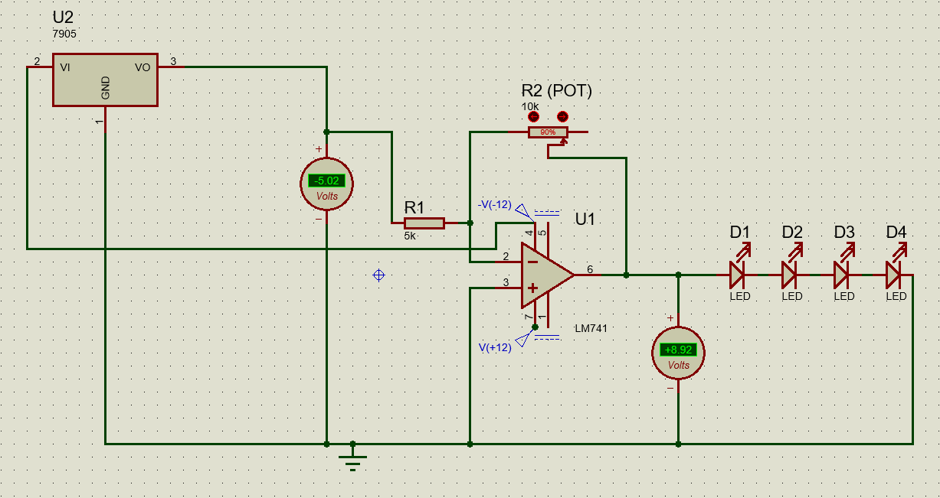

*Figure 13*

Thanks to this, the functionality has been verified and potential problems have been identified in advance.

1. Setup:

* The components are placed on a breadboard.

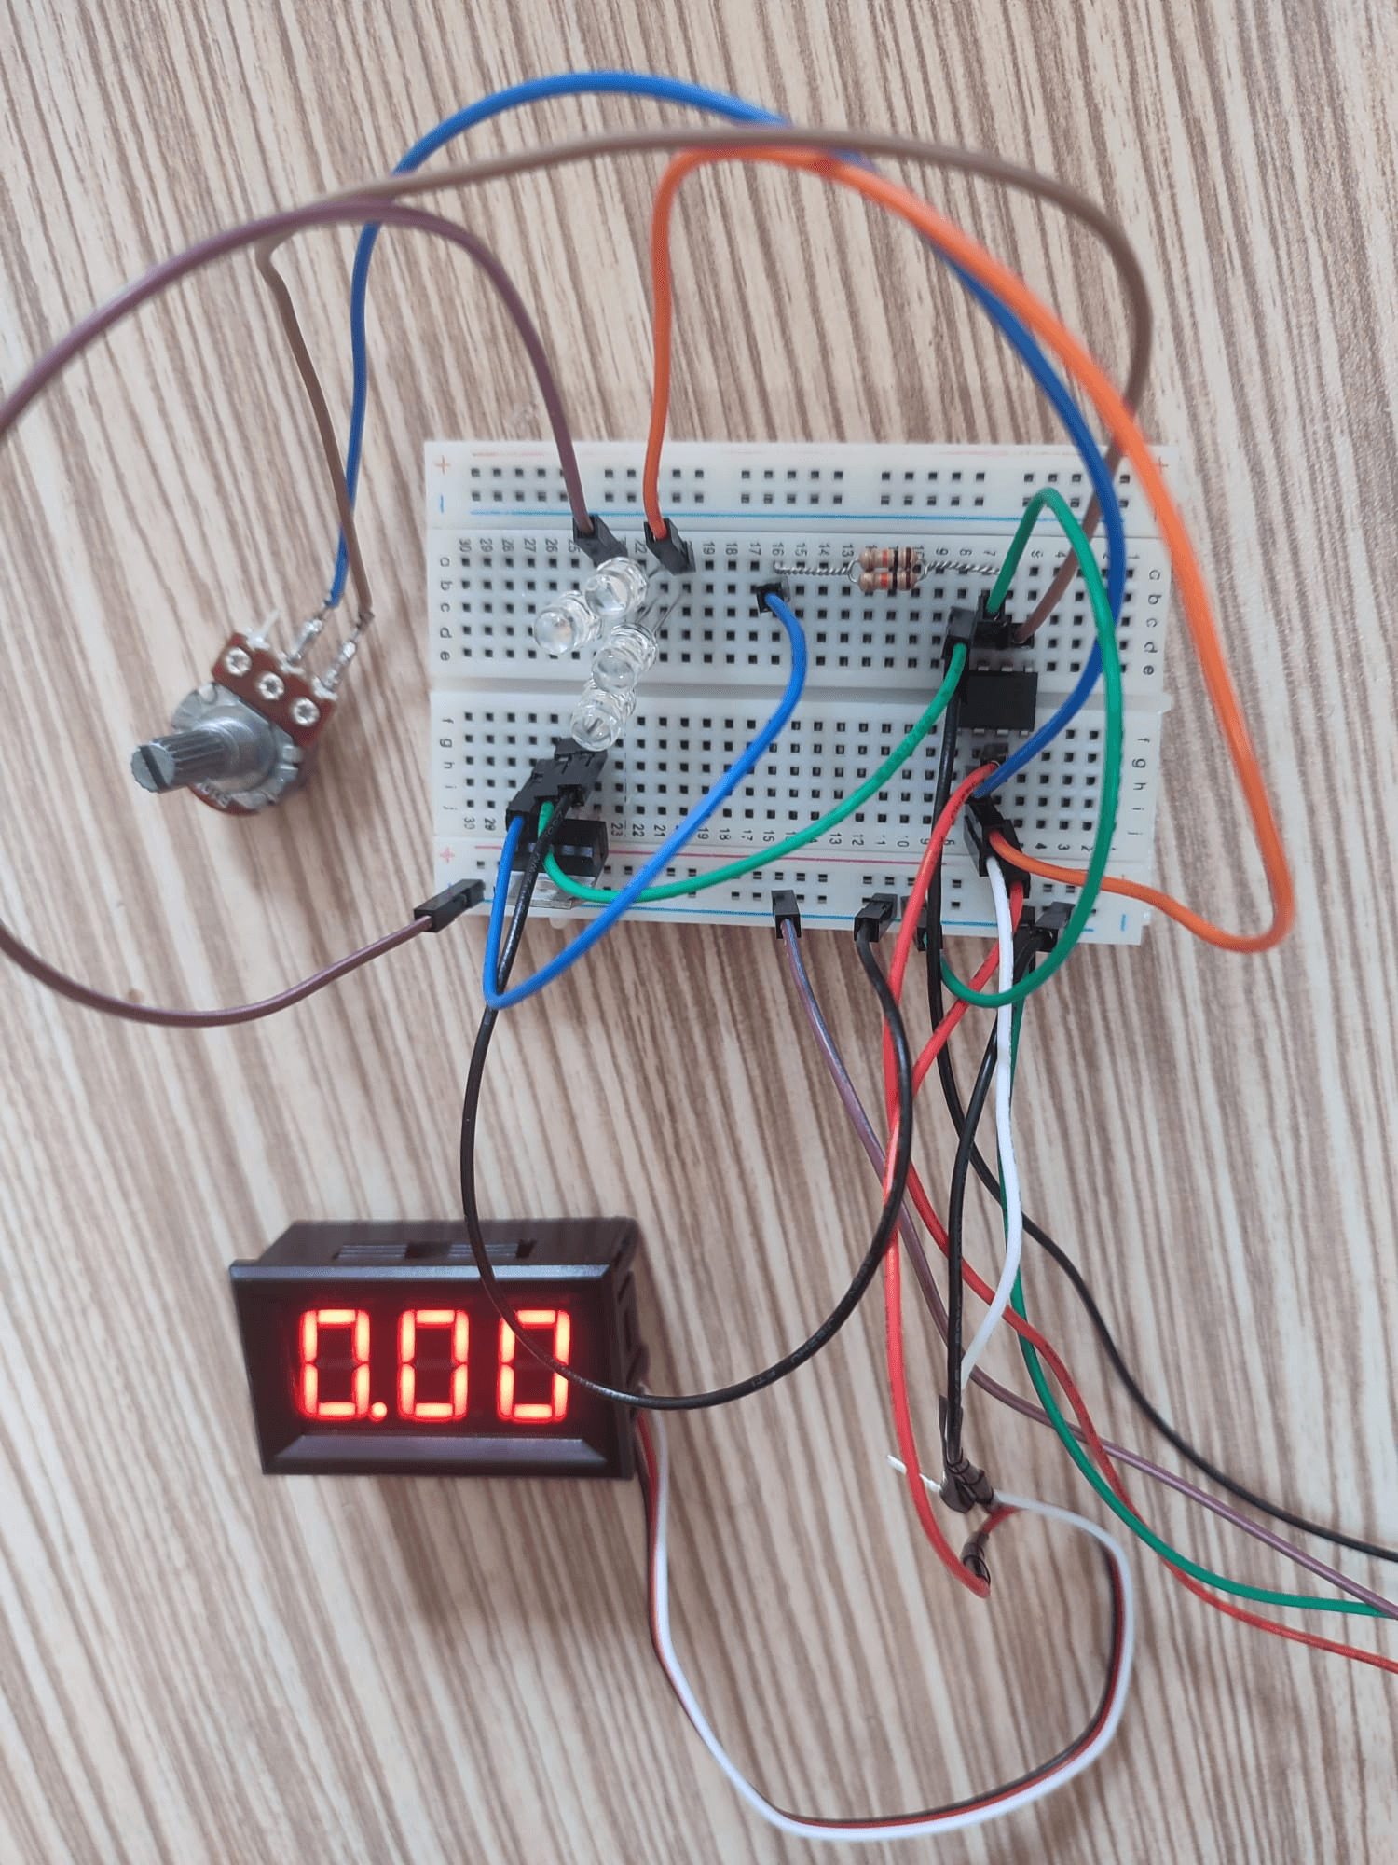

*Figure 14*

* Then the connections were soldered to secure and insulated with insulating tape to prevent short circuits.

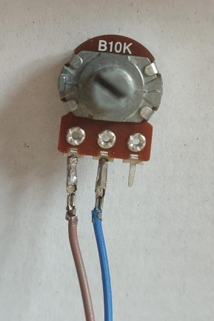 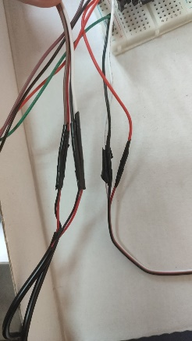

*Figure 15 Figure 16*

* The LM741 is connected to provide a reference voltage of -5V to the inverter input. The potentiometer is configured for feedback between the output and input.

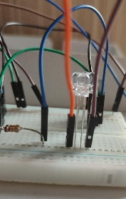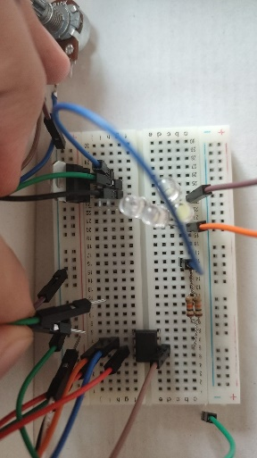 (blue cable)

*Figure 17*

* The LEDs are connected by being correctly oriented according to the positive output voltage. *Figure 18*

1. Test:

* The circuit is started and the output voltage is measured throughout the December of the potentiometer.
* The brightness control of the LEDs has been optimized and a smooth change between 0V (no lighting at all) and 9.23V (maximum brightness) has been achieved.

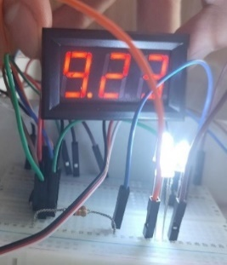 *(Figure 19)*

The principles learned in the Circuit I course have enabled the project to achieve its goals with adjustable voltage regulation and control.

1. Circuit as computational:

In this circuit, the output voltage is adjustable thanks to a potentiometer (10 kΩ) used to adjust the gain of the LM741 OPAMP.

The circuit was applied to the inverter input of the -5V, LM741, provided by the 7905 regulator. The gain of the LM741 depends on the ratio of the feedback resistance (R2) to the constant input resistance (R1 = 5 kΩ). With the potentiometer, this ratio can be adjusted between R2/R1 = 0 and 2.

The output voltage is calculated as follows: Vout = -K·Vin

* Vin = -5V,
* K = R2 / R1.

In this case: Vout=5·K

When the gain K is changed from 0 to 2, the output voltage is obtained from 0V to 10V.

**3.4** **Algorithm and Programming**

In this project, an algorithm and a program have been developed to simulate the behavior of the LM741 operational amplifier. The program calculates the output voltage (Vout) according to the input voltage (Vin), constant resistance (R1) and variable resistance (R2) values received from the 7905 negative voltage regulator.

**Basic Features of the Algorithm**

1. Mathematical Model: The program uses the following formula:

This relationship calculates how the output voltage is affected as R2 changes.

1. Simulation and Loop: The program simulates the R2 values by iterating Decently from 0Ω to 10kΩ in 1kΩ steps and calculates the output voltage for each step.
2. Output Voltage Decrement: Results are limited to ensure that the output voltage stays between 0–10V, which is the designed.
3. User Interaction: At the end of the simulation, the user is asked if he wants to save the results to a file.

**Important Parts of the Code**

1. Calculation Function:

double calculateOutputVoltage(double inputVoltage, double R1, double R2) {

return -(R2 / R1) * inputVoltage;

}

This function applies the mathematical formula to calculate the output voltage.

1. R2 Üzerinde Döngü:

for (R2 = 0; R2 <= 10000; R2 += 1000) {

double gain = R2 / R1;

double outputVoltage = calculateOutputVoltage(inputVoltage, R1, R2);

}

This loop calculates the gain and output voltage for each R2 value.

1. Limiting the Output Voltage:

if (outputVoltage > 10.0) outputVoltage = 10.0;

if (outputVoltage < 0.0) outputVoltage = 0.0;

This section prevents the output voltage from exceeding the designed limits.

1. File Output and User Selection: The program saves the results to a file and asks the user if he wants to keep this file:

char saveResults;

printf("\nDo you want to save the results to a file? (y/n): ");

scanf(" %c", &saveResults);

if (saveResults == 'n' || saveResults == 'N') {

remove("module_2_result.txt");

printf("Results discarded.\n");

} else {

printf("Results saved to 'module_2_result.txt'.\n");

}

Contribution to the Project

This program accurately simulates the circuit behavior, allowing to predict the output voltage for different gain settings. It also helps to verify theoretical calculations and makes testing processes more efficient during real-world application.

**3.5 Integration and Overall Effort**

During the project, the knowledge gained from different courses was integrated and applied. The targeted design was carried out by combining OpAmp circuit design, mathematical calculations, physical principles, circuit analysis and programming basics decently. The biggest challenge has been the inability to fully control the circuit output voltage. However, this problem was solved by adding a voltmeter to the circuit and a system that can be adjusted within the desired value was obtained by continuously monitoring the output voltage. Each stage of the project has been supported by the practical applications of the theoretical knowledge acquired and has been completed with a successful result.

**3.6 Discussion**

The most important support of the project has been the knowledge and skills gained from Circuit I and Physics courses. The basic principles learned from these courses played a critical role in the circuit design and application stages. The biggest difficulty in the project process has been the waste of time experienced due to the printed circuit design and material compatibility. Additional settings and some additional components were required for the Proteus simulations to fully match the actual circuit. Oct. In the future, it may be proposed to develop a more flexible control system by adding a microcontroller-based PWM (Pulse Width Modulation). Thanks to this, the circuit can have a wider range of uses in different application scenarios.

**4. Discussions**

**4.1 Limitations and Constraints**

Several limitations and restrictions were encountered during the project process. First of all, although the project was planned to be completed in 1-2 weeks, it was completed in 4 weeks due to various glitches. Delays in the material supply process have caused a loss of time, especially in the supply of critical components such as 12 V, 1 A adapter, 7905 voltage regulator. In addition, due to the limited hours of laboratory use, the studies had to be carried out at a decently paced pace between 16.00 and 24.00 at night with special permission from the faculty. These restrictions have extended the project duration and required additional efforts.

**4.2 Health and Safety Issues**

* The ends of all cables are covered with insulated tape.
* Accidental contact has been prevented by using a female jumper at the power inputs.
* By adding a safety switch at the inputs of the adapters, the voltage leading to the circuit or circuit exit is quickly disconnected.

**4.3 Legal Issues**

* There is no special patent or copyright for the tools and components used in the circuit.
* The project is open source and can be developed and used freely by everyone.

**4.4 Economic Issues and Constraints**

* Material costs (OpAmp, voltmeter, LEDs, etc.) are between Dec. 1000-1500 TL.
* Additional components had to be purchased during the trial and error stages.
* No additional venue fee has been paid due to the use of the university laboratory.

**4.5 Sustainability**

* The energy source of the circuit has been created by reusing the adapters that are idle at home.
* The design of the project will be shared on Github and thus everyone will be encouraged to develop or adapt the project.

**4.6 Ethical Issues**

* The principle of academic integrity has been followed in the project, information sources and references are indicated at the end of the report.
* It is aimed to make an open source sharing for the benefit of society.

**4.7 Multidisciplinary Collaboration**

* Although this project was carried out by a single person, electronics (OpAmp circuits), physics (electrical principles), mathematics (Calculus) and programming logic (algorithmic overview provided by C/C++) were used decoupled..

**4.8 Real-World Problem Solving**

* **Night Lighting:** By obtaining comfortable and low brightness light, the negative impact of night metabolism is minimized.
* **Savings:** Energy savings are achieved without the need to use traditional high-lumen bulbs for short-term needs.
* **Military Application:** In combat situations, it has the potential to make target detection difficult by emitting minimal light inside the house or trench.

**4.9 Alignment with Industry Applications**

* **Defense Industry:** It can be used in environments with low power consumption and minimal light emission needs.
* **Automotive and Mobile Applications:** Thanks to the battery or battery-powered portable version in the future, it can be used in camping environments or mobile lighting requirements.
* **Energy Sector:** In applications focused on energy saving, low-voltage and adjustable lighting offers an important advantage.

# Margin of Error Classification

Measured Output Voltage: 11.3V

Theoretical Output Voltage: 10V

Percentage Error Calculation:

The error percentage (%E) is calculated by the following formula:

% E = [(Measured Value - Theoretical Value) / Theoretical Value] × 100

**Calculation:**

Find the difference: 11.3 - 10 = 1.3

Divide the difference by the theoretical value: 1.3 / 10 = 0.13

Multiply the result by 100: 0.13 × 100 = %13

**Error Rate Description**

One of the main reasons why the measured value differs from the theoretical value is that the resistance R1 (5 kΩ) shows a result lower than the nominal value. Theoretically, we aim to determine the gain as 2 with the formula (K = R2/R1). However, since the measured value of the R1 resistance is around 4.5-4.7 kΩ, the gain value is higher than the theoretical value. This causes the output voltage to be higher than expected.

In addition, the fact that all elements used in the circuit have a tolerance value of 5% also leads to deviations in the measurement results. Oct. In particular, the tolerances in the resistors affect the gain calculations and therefore the output voltage. This error is due to the tolerance and accuracy of measuring devices.

In the error rate calculation, the theoretical output voltage was targeted as 10V, but the measured output voltage was obtained as 11.3V. This is due to small deviations in the gain and tolerances of the circuit elements. Lower tolerance components or precision measuring devices can be used to minimize such deviations in the circuit design.

# As a result

This project shows how OpAmp circuits can be used in low voltage lighting applications. Thanks to this simple but effective design, energy savings can be achieved and comfortable lighting that protects eye health can be offered at night. Application areas and functions of the project can be enriched with future developments.

**References**

1. Texas Instruments. (2016). *LM741 Operational Amplifier Datasheet*. Retrieved from [www.ti.com](https://www.ti.com/)
2. ON Semiconductor. (2017). *7905 Voltage Regulator Datasheet*. Retrieved from [www.onsemi.com](https://www.onsemi.com/)
3. Boylestad, R. L., & Nashelsky, L. (2015). *Electronic Devices and Circuit Theory* (11th Edition). Pearson Education.
4. Floyd, T. L. (2017). *Principles of Electric Circuits: Conventional Current Version* (10th Edition). Pearson.
5. Proteus Design Suite. (2023). *Circuit Simulation and PCB Design Software*. Labcenter Electronics. Retrieved from [www.labcenter.com](https://www.labcenter.com/)
6. Sedra, A. S., & Smith, K. C. (2015). *Microelectronic Circuits* (7th Edition). Oxford University Press.
7. Horowitz, P., & Hill, W. (2015). *The Art of Electronics* (3rd Edition). Cambridge University Press.